**Press release**   
*Specialist press*

**Admir Dobraca is new CEO of Kautex Machines Inc. (USA)**

**Admir Dobraca has taken over management of Kautex Machines in USA in February, 2020. He succeeds Bill Farrant, who successfully managed and developed Kautex Maschinenbau's North American site for a decade.**

Dobraca has many years of experience in the plastics industry and is a proven packaging specialist. Most recently, he worked for Retal PA LLC, a supplier of packaging products and solutions to the food and beverage industry. He began his career in the plastics industry at Husky Injection Molding Systems in 2002. He held various different positions there, with placements in North America and Europe, until 2016.

With Dobraca in the lead, Kautex aims to strengthen its strong market position in the North American packaging segment and expand into new markets. To achieve this, the company will improve its product and service offerings for current and future customers.

Thomas Hartkämper, CEO of the German parent company, Kautex Maschinenbau, is confident that Dobraca is the right person for the job: "Admir brings a lot of experience from the plastics industry and is a complete specialist in the packaging sector. He has a clear vision of how we can strengthen and expand our position in the North American market". Andreas Lichtenauer, CSO of the Kautex Group, agrees with the decision to select Dobraca, but is also grateful for Bill Farrant’s efforts when he was in the job: "We appreciate his profound knowledge of the industry, gained over many years, and are pleased with his achievements".

Dobraca is optimistic about his new task and working with a dedicated team of experts: "The Kautex Group shows a great development, especially in the packaging segment. I am glad that I will have the opportunity to make a personal contribution to the success of this innovative company and grow its strong market position in North America. But of course, that must not be at the expense of the other important segments".

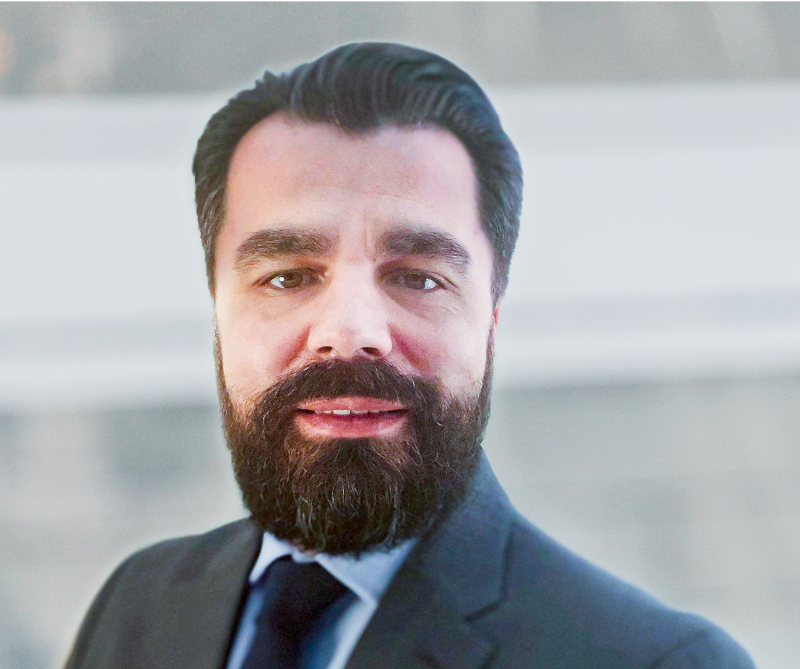

**Caption:**  
Admir Dobraca

**About Kautex Maschinenbau**Eight decades of providing its customers with innovative products and services have turnedKautex Maschinenbau into one of the world's leading companies in extrusion blow molding technology. With customers that include major automobile manufacturers and suppliers, and as well as companies working in the packaging industry. All of them have come to rely on the knowledge and experience of a brand that stands for both quality and reliability. In addition to its HQ in Bonn, a Customer Service Center in Berlin and regional offices in the USA, Russia, China, Italy, India, Mexico and Malaysia, Kautex Maschinenbau operates an extensive global network of service and distribution offices. **Contact details**  
**Christian Kirchbaumer**  
Head of Marketing Communications

**Kautex Maschinenbau GmbH**  
Kautexstr. 54  
53229 Bonn  
Germany

T +49 228 489370

christian.kirchbaumer@kautex-group.com